**Join me in June for AWS re:Inforce 2023 in Anaheim, CA**



I extend a warm invitation to you as registrations are now open for the [AWS re:Inforce 2023](https://reinforce.awsevents.com/?trk=direct) conference in [Anaheim Convention Center](https://www.anaheim.net/1117/Anaheim-Convention-Center) which will commence in less than 50 days time!

I have especially prepared this attendee guide for Builders, Data Scientists, Data Analysts, Developers, Architects and Business Professionals to help you navigate the conference which commences on Tuesday 13 June and concludes on Wednesday 14 June and maximize your learning experience to build that security framework and innovate with new insights as you learn from AWS Customers with real use cases.

AWS re: Inforce 2023 conference is curated for your specific needs to educate AWS customers with technical deep dives, business enablement content for C-suite, decision makers and provides generalist content suitable for builders and non-technical audiences to meet your security needs. You will receive hands-on learning opportunities and be able to participate in interactive sessions to help you build a culture of security, acquire knowledge in best practice and implement solutions for your organization.

Over two-days you will be able to choose from six session tracks:

* [Application Security](https://reinforce.awsevents.com/learn/catalog-preview/)
* [Data Protection](https://reinforce.awsevents.com/learn/catalog-preview/)
* [Governance, Risk and Compliance](https://reinforce.awsevents.com/learn/catalog-preview/)
* [Identity and Access Management](https://reinforce.awsevents.com/learn/catalog-preview/)
* [Network and Infrastructure Security](https://reinforce.awsevents.com/learn/catalog-preview/)
* [Threat Detection and Incident Response](https://reinforce.awsevents.com/learn/catalog-preview/)

**Build your own agenda**

I recommend that you start building your customized agenda now from the [session catalog](https://reinforce.awsevents.com/learn/catalog-preview/) that you may preview to ensure that won’t miss any of the popular learning experiences that include breakout sessions, workshops, chalk talks, code talks and lightning talks that may fill up quickly. You may register at this [link](https://reinforce.awsevents.com/learn/breakout-content/).

**Highlights**

This attendee guide is focussed on ensuring that you have a most enjoyable, interactive and memorable experience at the conference, allowing you to incorporate different [tracks](https://reinforce.awsevents.com/learn/catalog-preview/) into your agenda for your use cases and speak to AWS security experts at the Expo.

**Keynote - CJ Moses,** **AWS VP and Chief Information Security Officer**

On Tuesday, 13 June, you will hear from AWS Vice President and Chief Information Security Officer [CJ Moses](https://twitter.com/mosescj58) provide a keynote in the morning at 9:00 am (PDT), be sure to check-in early to secure a good seat and be ready to take note of the latest announcements for your security needs.

**Breakout Sessions**

[**APS302**](https://reinforce.awsevents.com/learn/catalog-preview/?trk=direct) **| From IDE to code review, increasing quality and security | Level 300**

In this breakout session you will be hearing from speakers Ifeanyi Okafor, Omer Tripp and Jas Chhabra discuss how to improve the quality and security of your code early in the development cycle. Explore how you can integrate Amazon Code Whisperer, Amazon CodeGuru reviewer, and Amazon Inspector into your development workflow, which can help you identify potential issues and automate your code review process.

Don’t forget to book into this interactive session if you would like to learn more about how to increase your developer productivity and explore the new tool AWS Code Whisperer an AI coding companion to understand how it can provide code suggestions for your security posture.

[**DAP401**](https://reinforce.awsevents.com/learn/catalog-preview/) **| Security design of the nitro system | Level 400**

In this breakout session you will hear from expert J.D. Bean discuss the AWS Nitro System and the underlying platform for all modern Amazon EC2 instances.

You learn about the inner workings of the Nitro System and discover how it is used to help secure your most sensitive workloads.

This session is fascinating to me for exploring the unique design of the Nitro System’s purpose-built hardware and how the hardware provides root of trust and a cryptographic system to ensure data integrity.

**Builders’ Sessions**

[**TDR353**](https://reinforce.awsevents.com/learn/catalog-preview/?trk=direct) **| Detecting suspicious activity in Amazon S3 | Level 300**

In this builders’ session you will hear from speaker Steve de Vera provide a guided simulation of suspicious activity within an AWS account involving unauthorized data exfiltration and Amazon S3 bucket and object data deletion.

This is a highly recommended session that will help you to learn how to detect and respond to malicious activity using AWS services like AWS CloudTrail, Amazon Athena, Amazon GuardDuty, Amazon CloudWatch, and non-traditional threat detection services like AWS Billing to uncover evidence of unauthorized use.

|  |
| --- |
|  |
| [**DAP353**](https://reinforce.awsevents.com/learn/catalog-preview/) **|** **Privacy-enhancing data collaboration with AWS Clean Rooms | Level 300**  In this builders’ session you will hear from speakers Ryan Malecky, Michael Santana, Akhil Aendapally, Ranjith Krishnamoorthy as they introduce AWS Clean Rooms to help you to protect sensitive data or eliminate raw data sharing.  I am looking forward to this session as you will be able to obtain hands-on experience with AWS Clean Rooms to learn how to query collective datasets and reduce the risk of exposing sensitive data from the underlying dataset. |

**Chalk Talks**

[**TDR431**](https://reinforce.awsevents.com/learn/catalog-preview/?trk=direct)**| The anatomy of a ransomware event | Level 400**

In this chalk talk will be hearing from speakers Megan O'Neil and Kyle Dickinson as they share the anatomy of a ransomware event that targets data residing in Amazon RDS and get detailed best practices for detection, response, recovery, and protection.

This is a much-anticipated session if you are interested in learning more about ransomware events and how to ensure that that you have appropriate measures for early detection and automated responses to limit your organization’s exposure.

|  |
| --- |
|  |
| [**IAM431**](https://reinforce.awsevents.com/learn/catalog-preview/?trk=direct) **| A tour of the world of IAM policy evaluation | Level 400** |

In this chalk talk you will hear from speakers Matt Luttrell and Daniel Peebles share beyond the basics of identity and access management (IAM) policy evaluation to focus on how policy evaluation works with some more advanced AWS features. I am keen to receive prescriptive guidance on what to do and what to avoid when designing authorization schemes and learn how policies are evaluated alongside AWS KMS key grants, Amazon S3 and Amazon EFS access points, Amazon VPC Lattice, and more.

**Workshop**

**Session Number | Building a DDoS-resilient perimeter and automatic protection at scale | Level 300**

In this workshop you will learn from speaker Dmitriy Novikov who will help you to acquire practical knowledge on how to build a DDoS-resilient perimeter, analyze logs to make informed decisions with Amazon Athena, and see how to use services like AWS Shield, AWS WAF, AWS Firewall Manager, and Amazon CloudFront to architect for DDoS resiliency and maintain robust operational capabilities that allow for rapid detection and engagement during high-severity events. This will an excellent session to help you learn how to detect and filter out malicious web requests, reduce the attack surface, and protect at scale with maximum automation and visibility.

**Code Talks**

[**DAP342**](DAP342:%20Protecting%20data%20in%20use%20with%20Cryptographic%20Computing%20for%20Clean%20Rooms) **| Protecting data in use with Cryptographic Computing for Clean Rooms | Level 300**

In this code talk, you will be hearing from speakers Andrew Kent and Bethany Rababy as they share cryptographic computing for clean rooms (C3R) which is a feature of AWS Clean Rooms that provides organizations the ability to protect data even while it is in use.

This will be a great code talk to further your learning with example queries and explanations of the C3R encryption client settings needed to run them to help you understand how to protect, use, collaborate and not share raw data.

[**GRC441**](https://reinforce.awsevents.com/learn/catalog-preview/?trk=direct)**| Proactive compliance in CI/CD pipelines with Amazon CodeCatalyst | Level 400**

In this code talk you be hearing from speakers Isaiah Salinas and Nereida Woo discuss how to implement proactive compliance in CI/CD pipelines using Amazon CodeCatalyst and AWS Config. This interesting code talk will be beneficial to help you to integrate applications that comply with industry standards and regulations using continuous integration and continuous delivery (CI/CD) pipelines.

**Lightning Talk**

[**TDR371**](https://reinforce.awsevents.com/learn/catalog-preview/?trk=direct) **| Security monitoring for connected devices across OT, IoT, edge & cloud | Level 200**

In this lightning talk you will hear from speaker Ryan Dsouza teach you how to stay ahead of cybersecurity threats and help IT leaders, CIOs and CISOs manage cybersecurity risks for all connected devices that includes operational technology. This will be an important lightning talk to join as you will learn how AWS makes it easier to monitor, detect, and respond to threats across the entire attack surface, which includes OT, IoT, edge, and cloud, while protecting your security investments in existing third-party security tools.

**Happy Hour | Tuesday June 13 - 4:00 PM– 5:00 PM (PDT)**

Pencil into your calendar and socialize with us on Tuesday 13 June at 4:00pm-5:00pm (PDT) during the happy hour at the Expo to listen to lightning talks over drinks and network with your peers.

**Closing reception**

Sit back, relax and enjoy the closing remarks on the last day of the conference. Join us from 6:00pm (PDT) as AWS executive team share final tips, learnings and highlights from the conference to better prepare you as you head back into your workplace armed with confidence and security knowledge to build steps to secure your data against threats and implement with tools for threat detection.

**Key dates**

* [Monday, June 12](https://reinforce.awsevents.com/agenda/?trk=direct)

|  |  |  |
| --- | --- | --- |
| **Time** | **What** | **Where** |
| 8:00 am – 5:00 pm (PDT) | Collect badge and Help Desk | Anaheim Convention Center |

* [Tuesday, June 13](https://reinforce.awsevents.com/agenda/?trk=direct)

|  |  |  |
| --- | --- | --- |
| **Time** | **What** | **Where** |
| 7:30 am – 7:00 pm (PDT) | Collect badge and Help Desk | Anaheim Convention Center |
| 7:30 am – 9:00 am (PDT) | **Breakfast** |
| 8:00 am – 5:00 pm (PDT) | Expo |
| 9:00 am - 10:30 am (PDT) | Keynote |
| 11:00 am – 5:00 pm (PDT) | AWS Builders’ Lab |
| 11:00 am – 6:45 pm (PDT) | AWS Breakout Sessions |
| 12:00 pm – 2:00 pm (PDT) | **Lunch** |
| 4:00 pm – 5:00 pm (PDT) | Happy Hour in the Expo |

* [Wednesday, June 14](https://reinforce.awsevents.com/agenda/?trk=direct)

|  |  |  |
| --- | --- | --- |
| **Time** | **What** | **Where** |
| 7:30 am – 8:00 pm (PDT) | Collect badge and Help Desk | Anaheim Convention Center |
| 7:30 am – 9:00 am (PDT) | **Breakfast** |
| 8:00 am – 5:00 pm (PDT) | AWS Builders’ Lab |
| 8:00 am – 6:15 pm (PDT) | AWS Breakout Sessions |
| 9:00 am – 4:00 pm (PDT) | Expo |
| 12:00 pm – 2:00 pm (PDT) | **Lunch** |
| 6:00 pm to 8:00 pm (PDT) | Closing reception |

**Places to visit and do**

To make your conference experience as enjoyable as possible, do allow plenty of time to familarize yourself with your agenda.

Secondly I recommend that you visit the expo and stop by the following areas:

1. [**AWS Village**](https://reinforce.awsevents.com/learn/expo/?trk=direct)

Visit the expo because this where the fun begins, choose your own adventure.

* ***AWS Training and Certification:*** you may use the sandbox environment and try self-paced labs to build your knowledge.
* ***AWS Village Theater*:** Speak to a security expert on any topic regarding your security needs.
* ***AWS Well Architected Security Practices:*** Learn best practice and recommendations for security.
* ***AWS Resilience***: Learn best practice for resilience.
* ***AWS Support:*** Learn best practice, how to detect vulnerabilities, prevent and remediate from incidents.

1. [**Activities**](https://reinforce.awsevents.com/learn/expo/?trk=direct)

Be sure to mix and match your day by including some of these activities into your agenda.

* ***AWS Compliance and Audit Acceleration Lounge****:* Immerse yourself in VR to experience security controls for customer data protection.
* ***AWS Builder’ Fair****:* Join the science fair and explore security use cases.
* ***Lightning Theatre:*** Join us for 15-minute demos.
* ***AWS Challenge Lounge:*** Put your security knowledge to the test and compete in fun challenges.
* ***AWS on Air:*** Drop by and watch the behind-the-scenes broadcast live throughout the conference.
* ***Startup Pavillion:*** Join lightning talks from founders as they discuss scaling security solutions.
* ***Cloud Operations Security Theater:*** Join lightning talks from AWS cloud operations experts and AWS Cloud Management Competency Partners.

**Watch last year’s keynote from AWS: reinforce 2022**

Chief Security Officer Stephen Schmidt at AWS: Reinforce 2022[here](https://www.youtube.com/watch?v=PPunA7tPMyk).

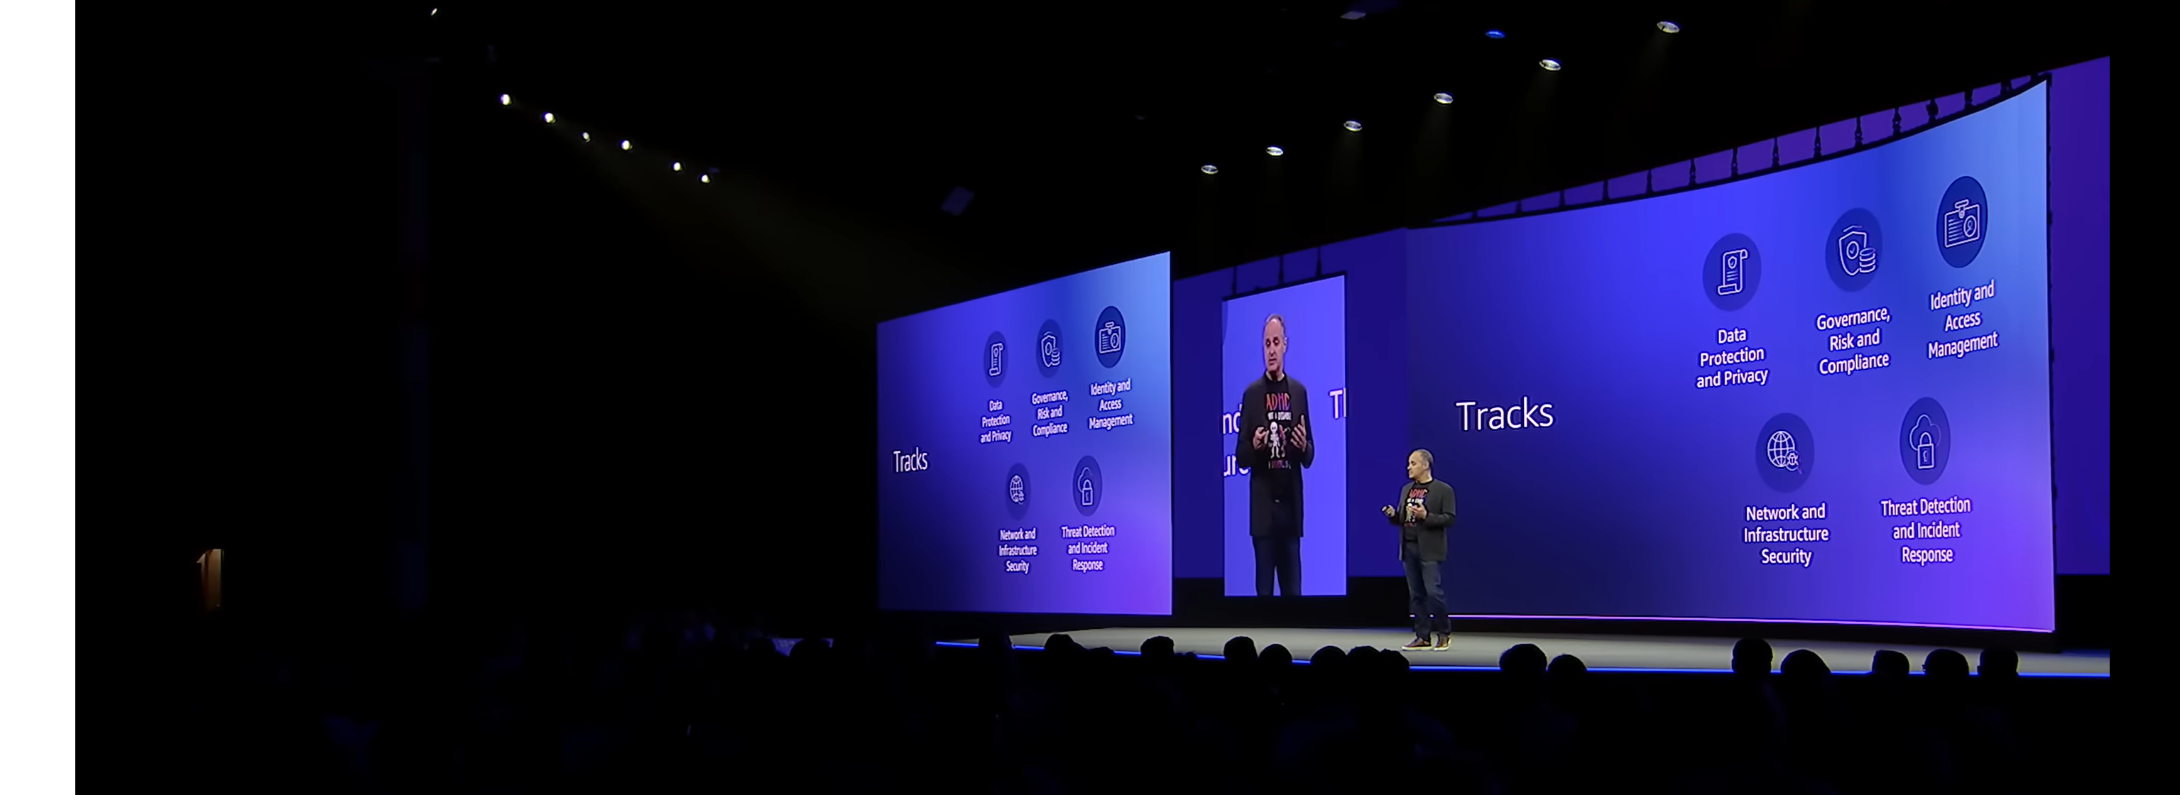

**Travel from Los Angeles Airport (LAX) to Anaheim Convention Center**

Here are some travel [options](https://www.rome2rio.com/map/Los-Angeles-Airport-LAX/Anaheim-Convention-Center) for you to explore. It is approximately a 42 minute drive from LAX to Anaheim Convention Center and the map below is courtesy of [Google Maps](https://www.google.com/maps/dir/Los+Angeles+International+Airport+(LAX),+1+World+Way,+Los+Angeles,+CA+90045,+United+States/Anaheim+Convention+Center,+800+W+Katella+Ave,+Anaheim,+CA+92802,+United+States/@33.8486257,-117.9189174,10.71z/data=!4m14!4m13!1m5!1m1!1s0x80c2b0d213b24fb5:0x77a87b57698badf1!2m2!1d-118.40853!2d33.9415889!1m5!1m1!1s0x80dcd7de5e18293d:0x3eb2a2ba13672914!2m2!1d-117.9209238!2d33.8008759!3e0).

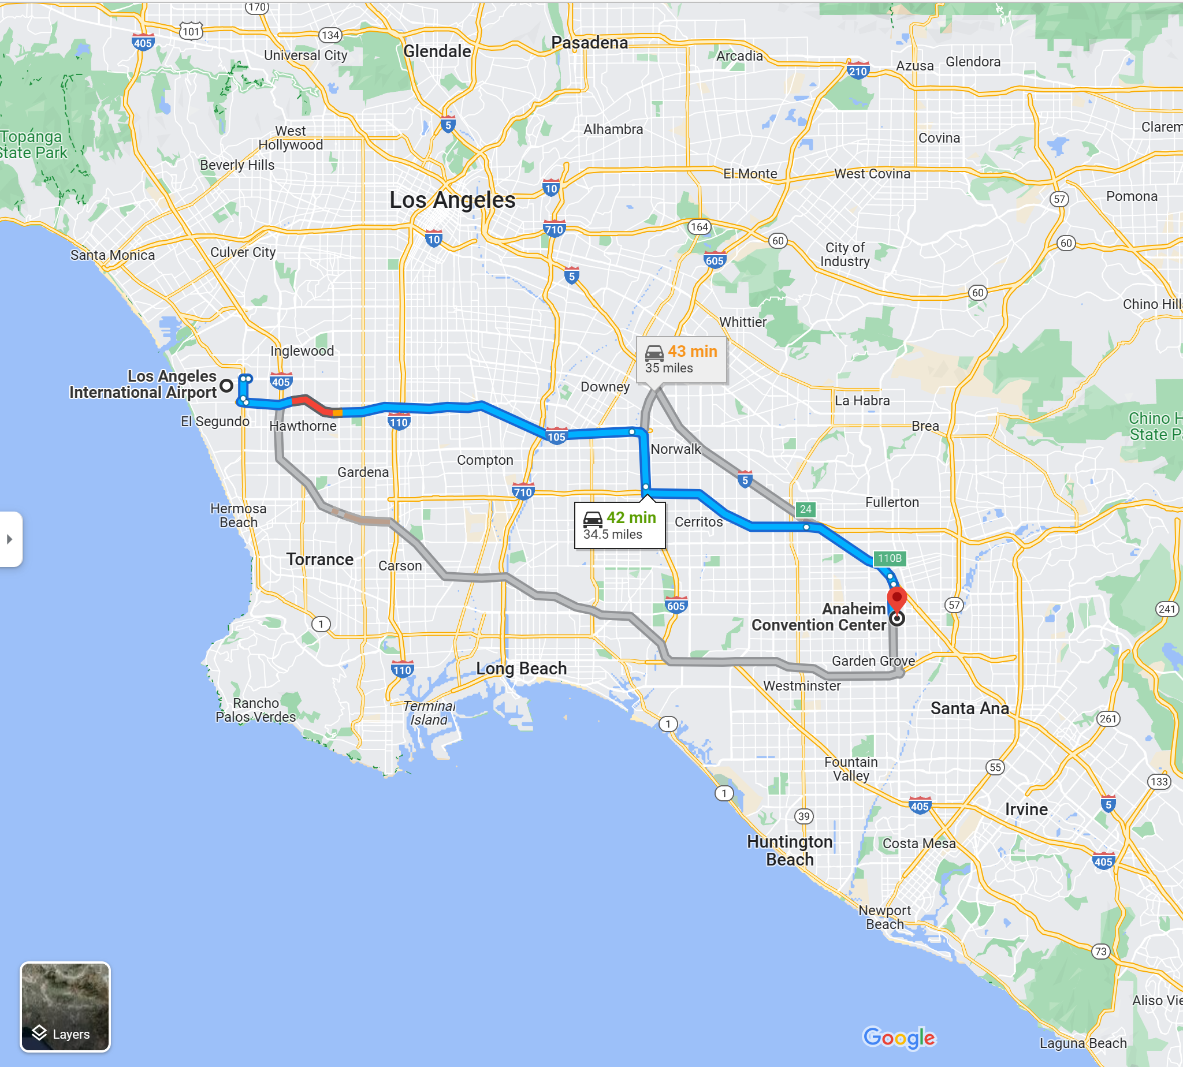

**Weather forecast**

AWS re:Inforce 2023 will commence on Tuesday 13 June and conclude on Wednesday 14 June. It will be Summer in sunny California and the weather in Arnaheim , CA is [forecast](https://www.weather25.com/north-america/usa/california/anaheim?page=month&month=June) to reach a high of 25 degrees celsius or 77 degrees fahrenheit.

**FAQs**

Please review the [frequently asked questions](https://reinforce.awsevents.com/faqs/?trk=direct) regarding the conference e.g. session catalog, booking hotel, registrations.

Hope to see you there at AWS: reinforce 2023 and don’t forget to wear a pair of comfortable shoes.

If you are unable to join us in-person, the keynotes and leadership sessions will be live streamed and further details will be provided closer to the event. The session catalog is in preview and is subject to change.

**Stay connected with the AWS Community**

* [AWS re:Inforce 2022 on Youtube](https://www.youtube.com/results?search_query=aws+re%3Aforce+2022)
* [Twitter](https://twitter.com/AWSSecurityInfo)
* [LinkedIn](https://www.linkedin.com/company/amazon-web-services/)
* [Twitch](https://www.twitch.tv/aws)
* [Instagram](https://www.instagram.com/amazonwebservices/)